Pembroke & District Amateur SWIMMING CLUB
HALL OF FAME

The swimmers and teams listed in our Hall of Fame are current swimmers or past swimmers and teams that have formed a very special place in the history of Pembroke Swimming club and have achieved very high, special achievements to merit inclusion into this Hall of fame (apologies to all those swimmers and teams that have been missed).

Teams
Page
- 1984 Junior School Team
- 1993South Wales Champions
- The Dream Team
- 2009 West Wales Boys Team
- 2010 Welsh Age Group Boys Team
- 2012 Welsh Boys Team

Page 1 1984 Junior School Team

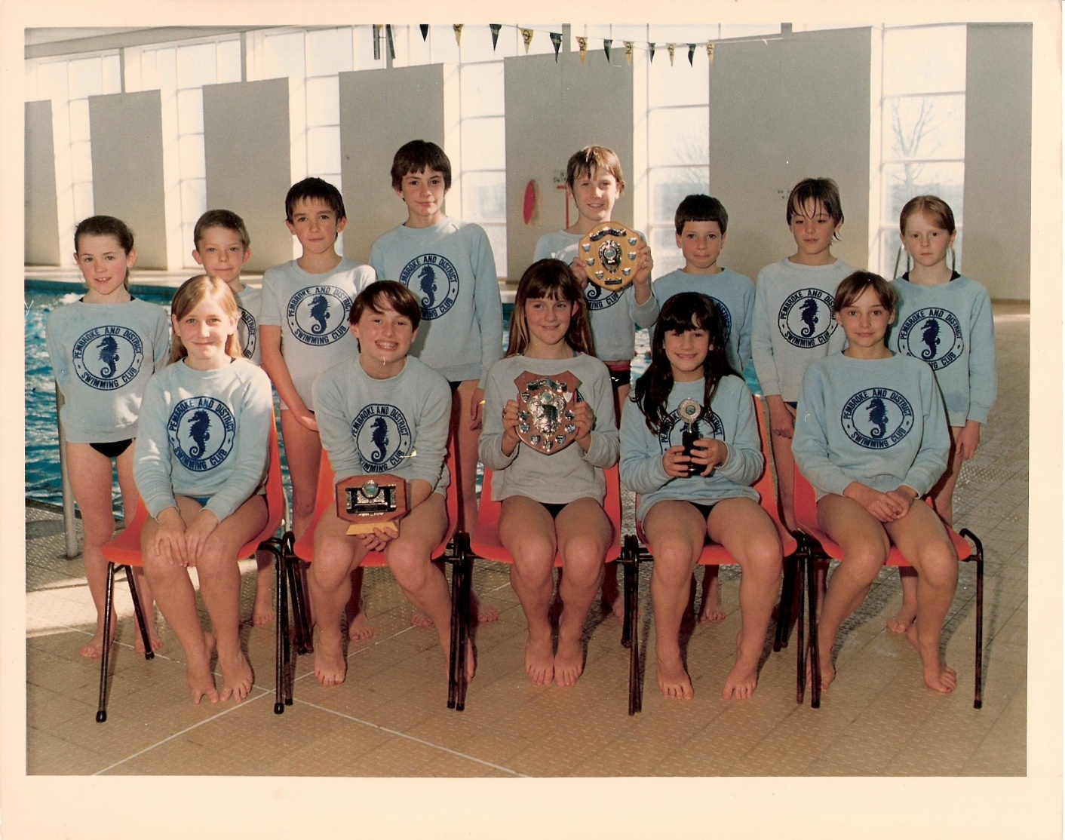
Pembroke & District Junior School Team 1984
Winners of Junior Boys, Junior Girls, Overall winners at Tenby
Back Left to Right
Catherine Thomas, Neil Hunter, Neil Lewis, Alison Coward, Daniel Overend, Nicholas ? Neil Spencer, Charlotte Bailey.
Front Left to Right
Wendy Brickle, Amanda Evans, Shirley Cole, Anna Morgan, Sharon Spencer.
This team was special as it was one of the first Pembroke & District School teams to be made up of entirely club swimmers. This team remained unbeaten for the whole year.

(Two swimmers Shirley Cole and Anna Morgan are in our individual swimmers hall of fame list)

Page 2 1993 South Wales League Winners

A great chapter in the history of our club.
The team went the whole 1993 season unbeaten and won the South Wales League. Under the head coach Gwyn Goforth helped by assistant Keith Thompson the club produced an excellent team with some very good swimmers that were more than a match for most clubs.
Unfortunately shortly after this the South Wales League along with the South Wales Junior League were disbanded which many feel was a great loss to club swimming.

Page 3 The Dream Team

Pembroke 12/13 yrs boys team was a special team that was never beaten in a medley race at any level they competed in. The boys medley team consisted of Daniel Casey Backstroke Huw Day Breaststroke David Thompson Butterfly Martin McNally Freestyle. In the freestyle team Huw Day often made way for Neil Hughes.
In 1995 the boys won the West Wales Medley relay in record time beating a Swansea team that boasted 4 age group winners and National qualifiers, they also and came 3rd in the freestyle. In 1996 the boys won both medley and freestyle in the Welsh National Schools Championships all in record time and from then on they called themselves The Dream Team. Shortly after this Huw a long and short course national breaststroke champion gave up his swimming and Daniel moved away to live with family in England.
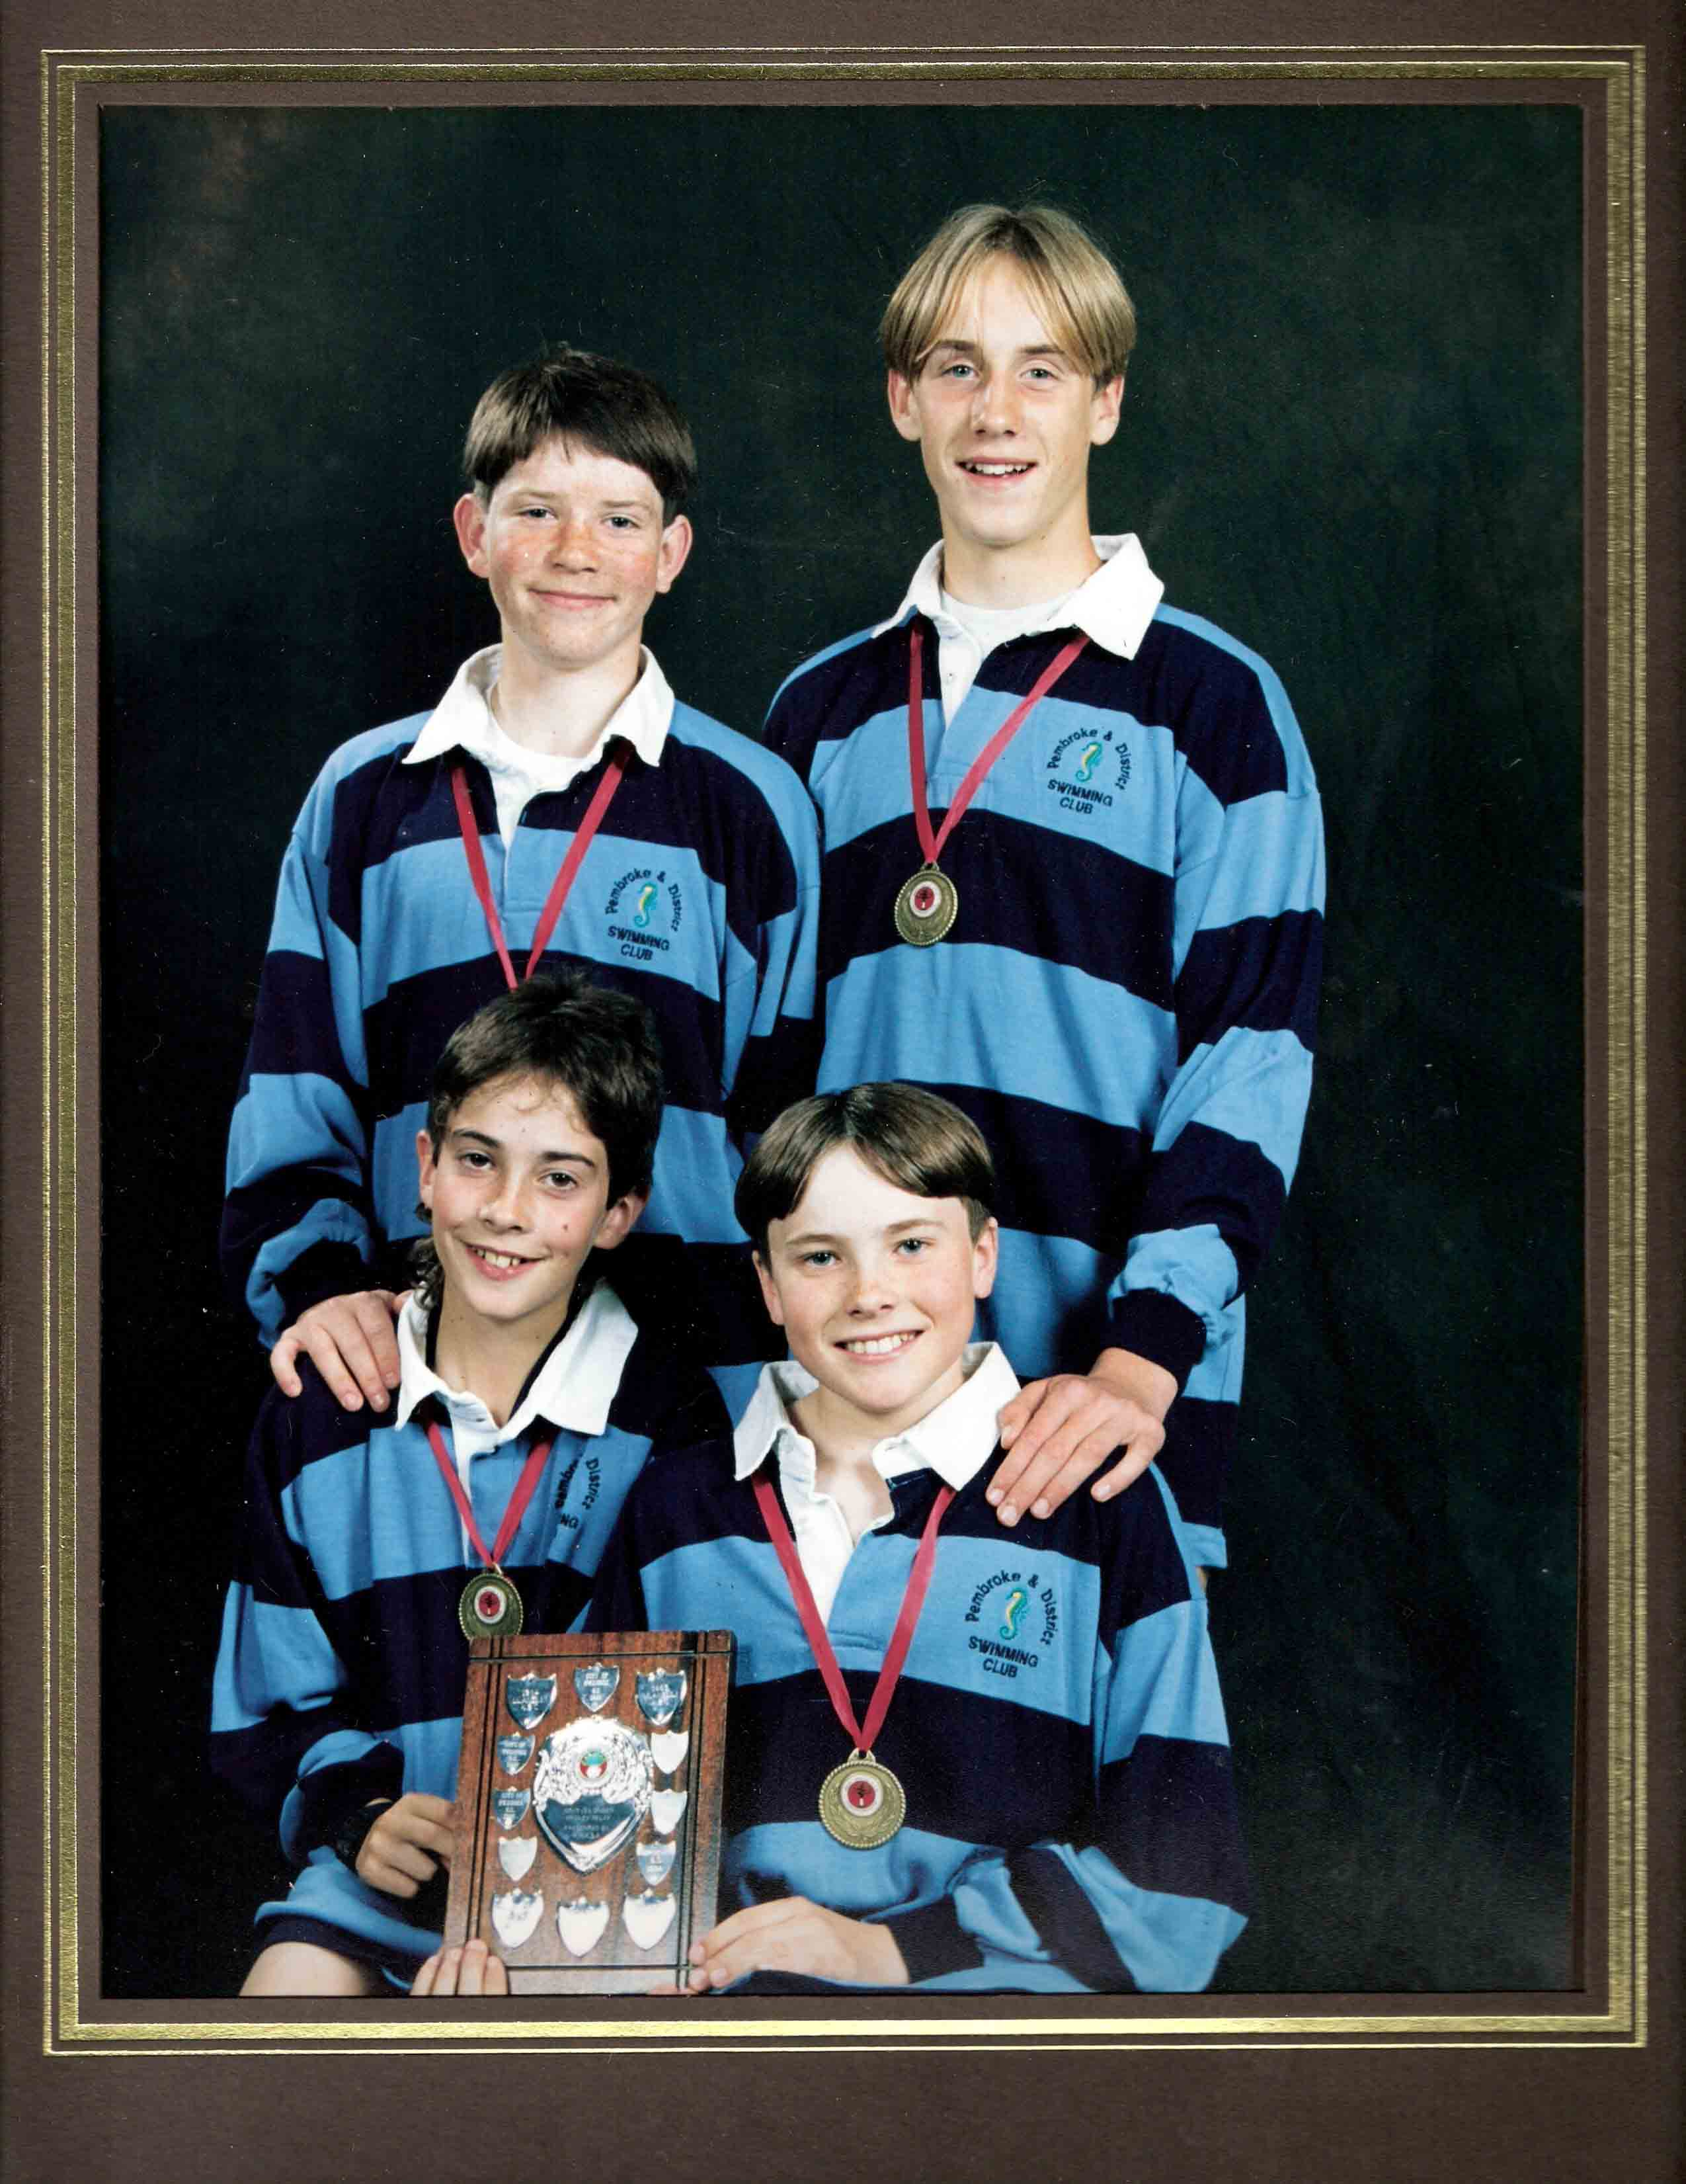
Top left Martin McNally, Huw Day
Bottom left Daniel Casey, David Thompson
(two of the team Huw Day and David Thompson are featured in the individual hall of fame files)

Page 4 2009 West Wales Boys Winning Relay Team

The 2009 West Wales Boys Relay team was the start of another golden time for Pembroke Swimming Club. Around this time the club started to produce so many future quality swimmers. This was the medley relay team of 2009. Shortly after this the Pembrokeshire Swimming started to enter County teams into the West Wales Championships so this may have been the last truly Pembroke team to win the at the Championships.

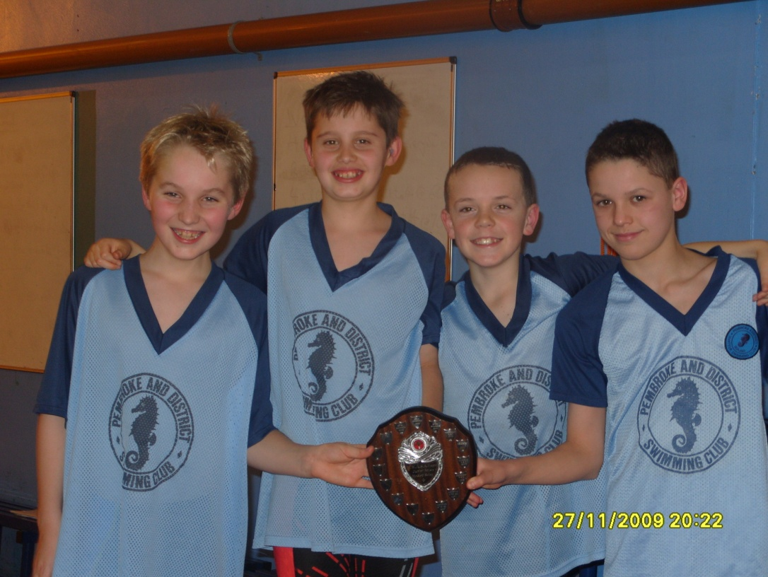

Left to Right
Jonathan Orchard, Oliver Crawford, Daniel Picton, Daniel Thomas

(Jonathan and Daniel Thomas are featured in the hall of fame individual files)

Page 5 2010 Welsh Age group boys team

Page 6 2012 Welsh National Champions

Swimming for Pembrokeshire Swimming this relay team consisted of all Pembroke Club Swimmers. This Team not only won the 4x100m medley event but set a new record time in the process

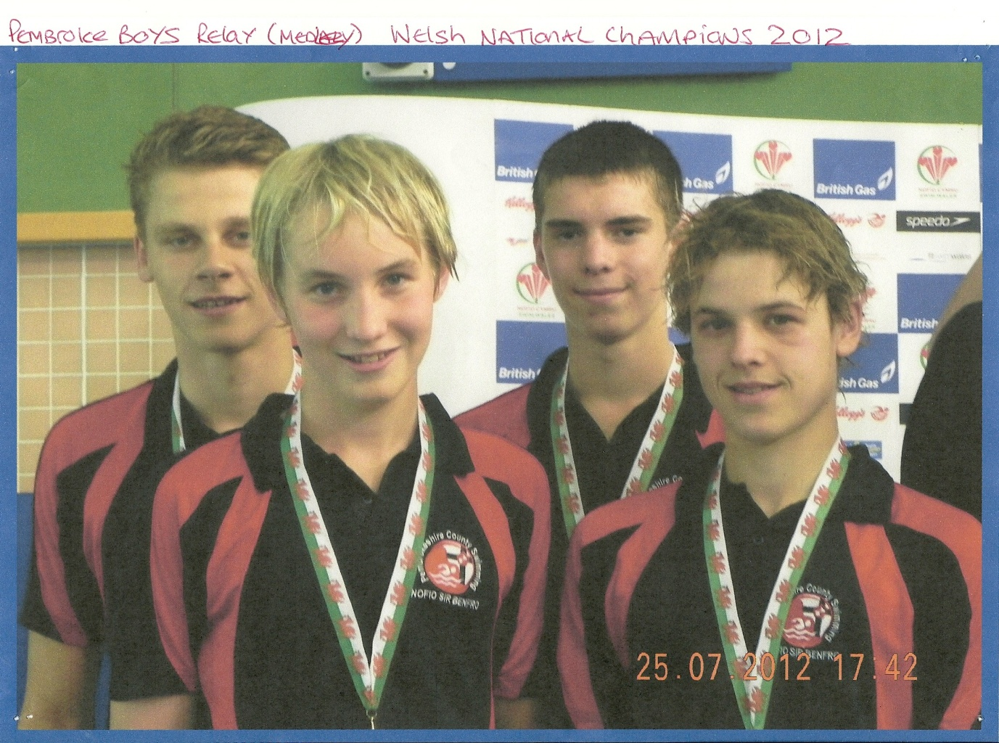
Left to Right
Micky Hire, Jonathan Orchard, Samuel Withers, Daniel Thomas.
(Micky, Jonathan and Daniel are featured in the hall of fame individual files)

